

Functional Specification Documentation

PricewaterhouseCoopers

Version No.: 1.0
Date: 06-Mar-15

Table of Content
1. Budget 1
2 Master Data Synchronization 5
3 Reports 6

Budget ( Due on 30 April 2014)

  - Overview

- Budget Set-up and Import
- Budget is at general ledger level to Business Unit (for IFS only), Operating Unit and Project
- Allow manual update of budget for OU, BU and project. This means that OU/BU sap user goes into the system to enter their respective budget and route for approval. Once approved budget is locked and cannot be change. System administrator can change the budget when needed.
- Control access to user for budget upload
- Import is at entity level ( per entity)

- Budget Control Validation

- Budget check is based on annual budget and at Purchase Order (PO) document (initial and reforecast budget)
- Validation Check
  - Check GL line amount against project budget (if project field is not null)
    - If U_AB_BUDGETEDCOST is equal to ‘YES’ then apply below validation else do not validate budget.
    - Validation as follows:
      - if it exceed budget ,update U_AB_BUDGETEXCEEDED to “YES”, then trigger approval matrix
      - If within budget then PO go through.
  - Check GL line amount against BU (IFS Budget) if project is null and BU is populated with IFS
    - If U_AB_BUDGETEDCOST is equal to ‘YES’ then apply below validation else do not validate budget.
    - Validation as follows:
      - if it exceed budget ,update U_AB_BUDGETEXCEEDED to “YES”, then trigger approval matrix
      - If within budget then PO go through.

  - Check GL line amount against OU budget (if project is null and BU is populated with Non-IFS)
    - If U_AB_BUDGETEDCOST is equal to ‘YES’ then apply below validation else do not validate budget.
    - Validation as follows:
      - if it exceed budget ,update U_AB_BUDGETEXCEEDED to “YES”, then trigger approval matrix
      - If within budget then PO go through.

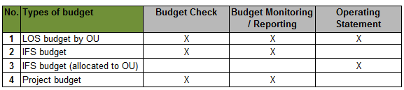

- Reforecast Budget

- Reforecast budget created and import to Sap
- Will be the basis for new budget control validation
- Add field in budget table to set active /inactive budget after import of reforecast budget

1.2 Template (Source Data)

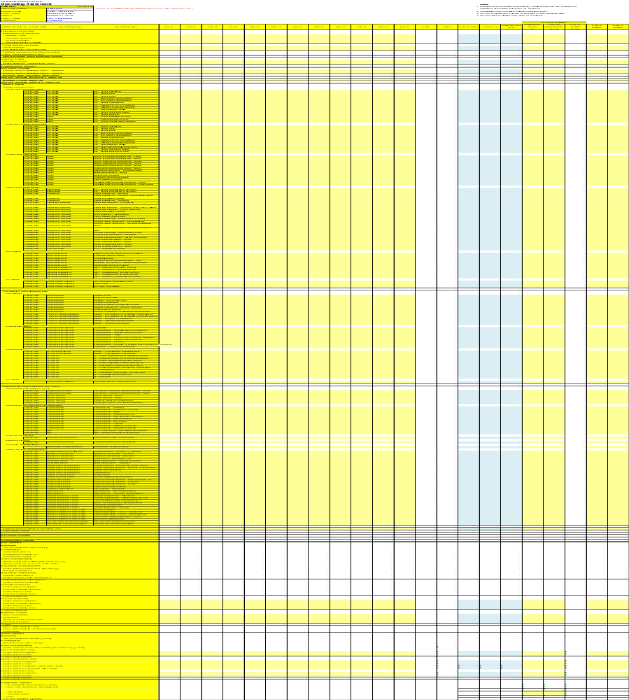

1.3 Mapping to Sap B1 System

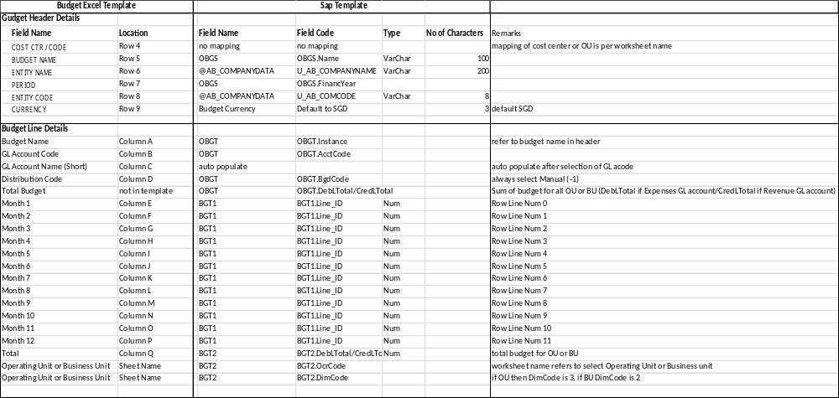

1.4 Process Details

- Create Budget as per Template
  - Original Budget and Reforecast Budget
- Template can have budget for different Operating Unit (OU) or Business Unit (BU)
- Each worksheet in template represent OU or BU budget or Project budget
- Use OU, BU or Project code in naming the each worksheet in budget template
- Total budget is sum of all OU/BU/Project budget
- Two (2) budget definition in a year
  - Original Budget – 1st upload at start of fiscal year
  - Reforecast Budget – 2nd upload during the fiscal year
- By default Original budget is set to active until reforecast budget is uploaded, then original budget should be set to Inactive
- Budget set as active will be the basis in budget control validation during creation of Purchase Order
- During import program will read each worksheet in the template and import data accordingly
- Import is per entity

Master Data Synchronization (Due on 15 April)

2.1 Master Data

- Chart of Accounts (OACT)
- Create / Update / Delete function replicate to all entities
  - OACT.ACCTCODE
  - OACT.ACCTNAME
  - OACT.ACTCURR
  - OACT.ACTTYPE
  - OACT.LOCMANTRAN
  - OACT.FINANSE
  - OACT.CFWRLVNT
  - OACT.DIM1RELVNT
  - OACT.DIM2RELVNT
  - OACT.DIM3RELVNT
  - OACT.DIM4RELVNT
  - OACT.EXPORTCODE
  - OACT.ACTIVE (Y/N)
  - OACT.INACTIVE (Y/N)
  - OACT.BUDGET
  - OACT.VATCHANGE
  - OACT.GROUPMASK
  - OACT.FATHERNUM
- Vendor/Customer Master Data (OCRD)
- Create / Update / Delete function replicate to all entities
  - OCRD.SERIES
  - OCRD.CARDCODE
  - OCRD.CARDNAME
  - OCRD.CARDTYPE
  - OCRD.GROUPCODE
  - OCRD.CURRENCY
  - OCRD.LICTRADNUM
  - OCRD.U_AB_WTAXREQ
  - OCRD.U_AB_WTAXREM
  - GENERAL TAB
    - OCRD.PHONE1, OCRD.PHONE2,OCRD.FAX, OCRD.E_MAIL, OCRD.CNTCTPRSN, OCRD.ACTIVE(Y/N), OCRD.INACTIVE(Y/N)
  - CONTACT PERSON TAB
    - OCPR.NAME ,OCPR.POSITION, OCPR.E_MAIL, OCPR.TEL
  - ADDRESS TAB
    - CRD.ADDRESS, CRD1.STREET, CRD1.BLOCK, CRD1.ZIPCODE, CRD1.COUNTRY
  - PAYMENT TERMS TAB
    - OCRD.GROUPNUM, OCRD.BANKCOUNTR,OCRD.BANKCODE, OCRD.DFLACCOUNT, OCRD.DFLSWIFT, OCRD.DFLBRANCH, OCRD.DFLIBAN
  - PAYMENT RUN TAB
    - OCRD.HOUSBNKCRY, OCRD.HOUSEBANK, OCRD.HOUSBNKACT, OPYM.PAYMETHCOD, OPYM.ACTIVE (Y/N)
  - ACCOUNTING TAB
    - OCRD. DebPayAcct, OCRD.VATSTATUS, OCRD.ECVATGROUP, OCRD.WTLIABLE
- Item Master Data (OITM)
- Create / Update / Delete function replicate to all entities
  - OITM.ITEMCODE
  - OITM.ITEMNAME
  - OITM.ITEMTYPE
  - OITM.ITMSGRPCOD
  - OITM.INVNITEM (DEFAULT UNCHECK)
  - OITMSELLITEM(DEFAULT UNCHECK)
  - OITM.PRCHSEITEM (DEFAULT IS CHECK)
  - OITM.ACTIVE (Y/N)
  - OITM.INACTIVE(Y/N)
  - OITM.U_AB_ITEMTYPE
  - OITM.U_AB_ITEMSUBGROUP
  - PURCHASE TAB
    - OITM.CARDCODE, OITM.BUYUNITMSR, OITM.VATGROUPPU
  - STOCK TAB
    - OITM.GLMETHOD, OITW.EXPENSESAC, OITW.FREXPENSAC, OITW.APCMACT, OITW.APCMFRNACT
  - PROPERTIES TAB
    - OITG.ITMSGRPNAM

  - REMARKS TAB
    - OITM.USERTEXT
- For Item Master uncheck Inventory and Sales Item button
- Default only as Purchase Item

- Dimension and Cost Center (OPRC)
- Create / Update / Delete function replicate to all entities
  - ODIM.DIMDESC
  - OPRC.PRCCODE
  - OPRC.PRCNAME
  - OPRC.DIMCODE
  - OPRC.EFFECTIVE FROM AND EFFECTIVE TO
  - OPRC.U_AB_ENTITY
  - OPRC.U_AB_REPORTCODE
  - OPRC.U_AB_ENTITYNAME
  - OPRC.U_AB_NATCOSTTYPE
- Purchasing Department (OSLP) / Department (OUDP)
- Create / Update / Delete function replicate to all entities
- If OSLP is created/updated auto update OUDP in the same database
  - OSLP.SLPNAME
  - OSLP.MEMO
  - OSLP.ACTIVE
- If OUDP is created/updated auto update OSLP in the same database
  - OUDP.CODE
  - OUDP.NAME
- Users
- Create / Update / Delete function replicate to all entities
  - OUSR.USER_CODE
  - OUSR.BINWITHMICROSOFTWINDOWACCOUNT
  - OUSR.U_NAME
  - OUSR.E_MAIL
  - OUSR.SUPERUSER
  - OUSR.MOBILEUSER
  - OUSR.DEPARTMENT
  - OUSR.PASSWORD
  - OUSR.ONELOGPWD
  - OUSR.LOCKED
  - OUSR.EMPLOYEE

2.2 Process Details
- Use main entity (PwC LLP) to create/update/delete master data
- When click Add/Update program should default the record as “InActive”
- Send email notification for created/updated records to master data reviewer/authorizer
- Authorizer review the records and change status to “Active”
- Display drop down selection for list of entities to auto update created/updated records ( refer to company data table)
- Provide button UI “Update” to execute program
- When click update program will create/update selected entities accordingly

Reports

3.1 Overview Details
- OSS text file (Delivery on 20 April)
- Operating Statement-Global/China (OS Summary) (Delivery on 20 April)
- LT YTD Report (Delivery on 20 April)
- LT MTH Report (Delivery on 20 April)
- Trial Balance Query (Delivery on 20 April)
- Customize report to list down GRN number, PO number, PO amount, invoice number, invoice amount, variance between PO amount and invoice amount (system to calculate if got variance) for each corresponding payment document reference." (Delivery on 10 April)
- Cost Allocation Report at line items (Delivery on 10 April)
- Aging Report at Purchase Order level (Delivery on 10 April)

3.2 OSS Text File

3.2.1 Report Format
- Report format output is txt file format
- Header details not shown in report(GL code, period etc)

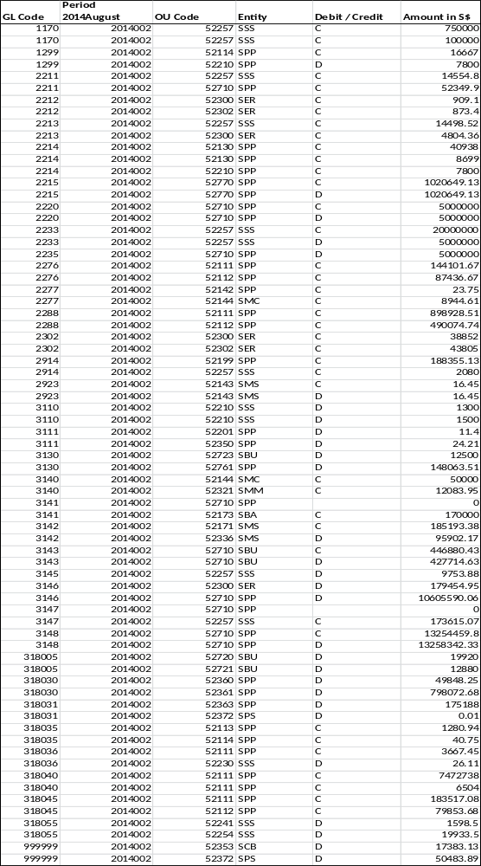

3.2.2 Sap Mapping

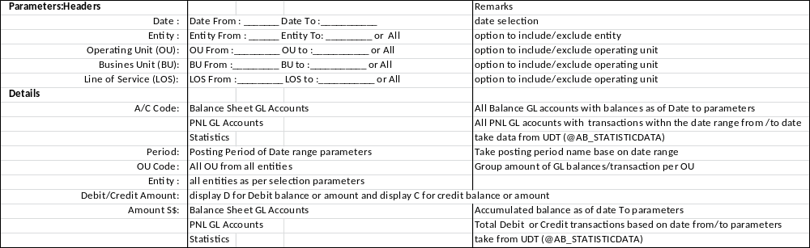

3.3 Operating Statement (Global/China)

3.3.1 Report Format at Dimension1 Level

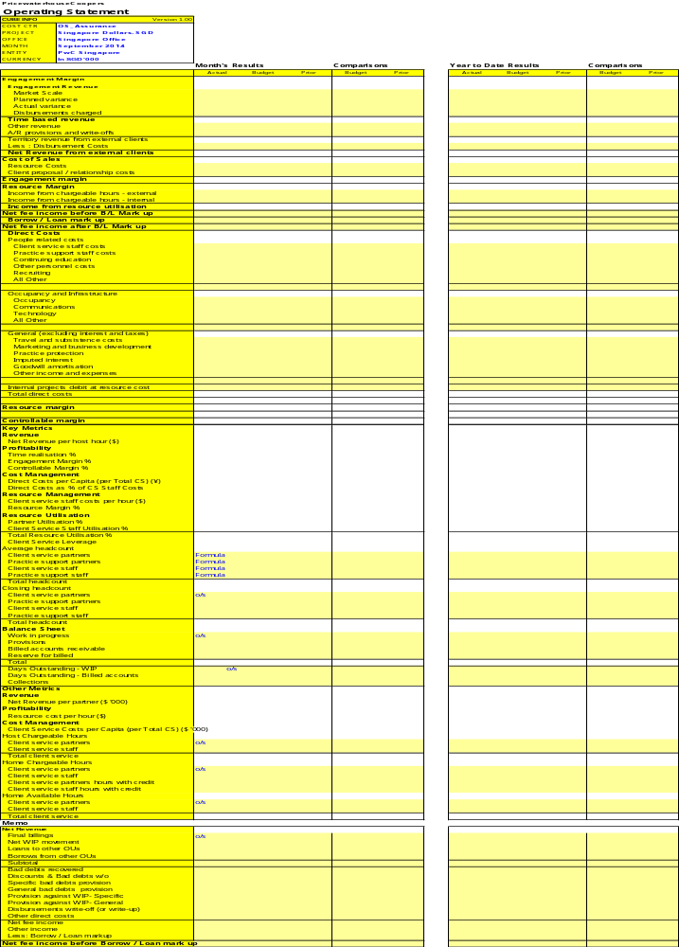

3.3.2 Report Format at Summary ( All Dimension 1)

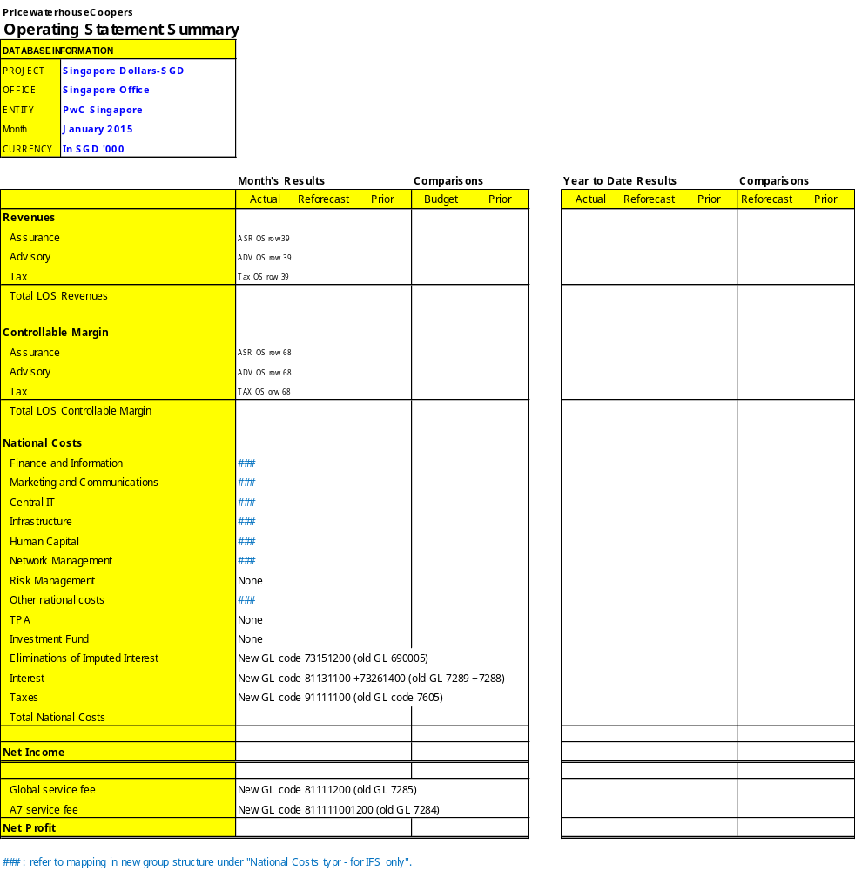

    - Report details and mapping
- Refer to attached excel report file name: FSD Report OS – worksheet name OS (FSD) and OS Summary (FSD)

3.4 LT YTD Report

3.4.1 Report Format

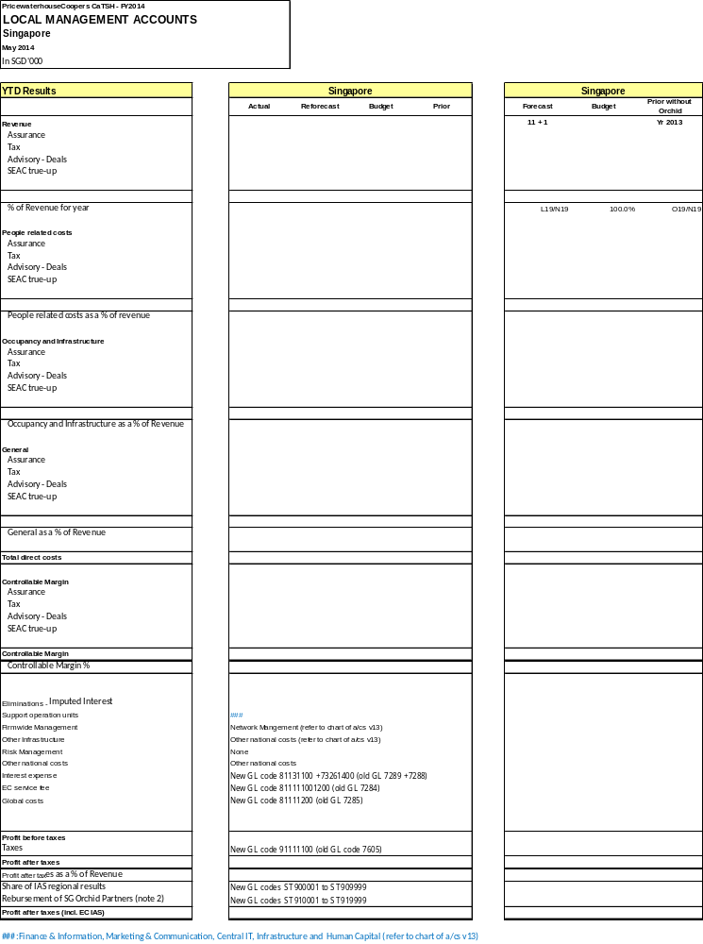

    - Report details and mapping
- Refer to attached excel report file name: FSD Report OS – worksheet name LT YTD (FSD)

3.5 LT MTH Report
3.5.1 Report Format

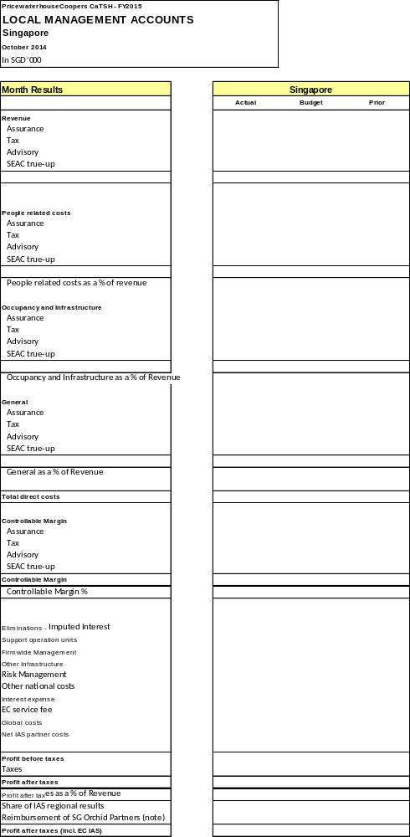

    - Report details and mapping
- Refer to attached excel report file name: FSD Report OS – worksheet name LT MTH (FSD)

  - Trial Balance Query

3.6.1 Report Format

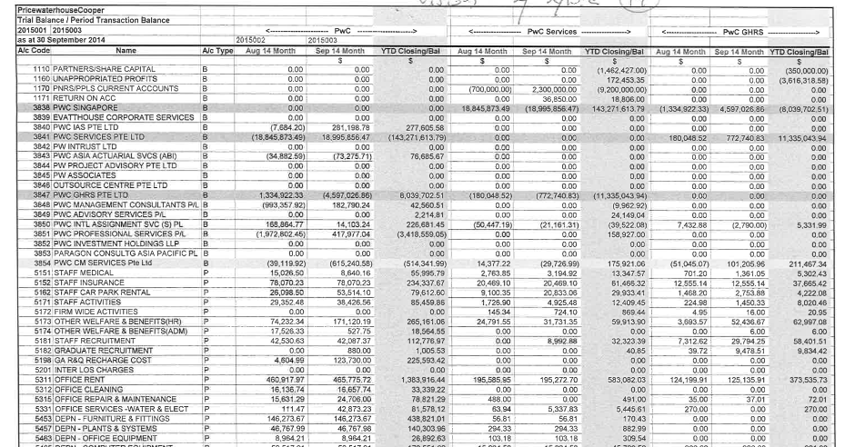

    - Report Details
- Parameters : Month Selection From /To
- Parameters : From Entity / To Entity
- Always display 2 months ( e.g. month selection is Sep 2014 , then display Aug 2014 and Sep 2014 in report per entity
- Each entity will have 3 columns
  - Previous month
  - Current Month – as per selection parameters
  - YTD Closing Balance – accumulated balances as of selection date
- The last 3 columns in the report should be the sum of the following:
  - Total Previous month (August 2014)
  - Total Current Month ( Sept 2014)
  - Total Year to Date

3.7 List of Paid Invoices (Outgoing Payment)

3.7.1 Report Format

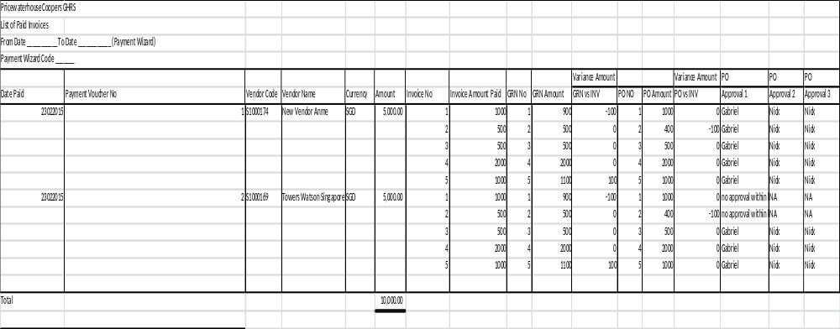

3.7.2 Sap Mapping

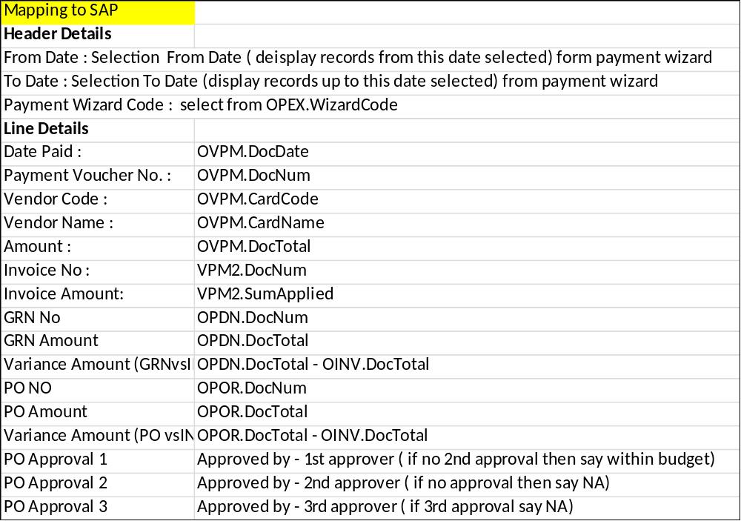

3.8 Cost Allocation Report at Line Items

3.8.1 Cost Allocation at PO level

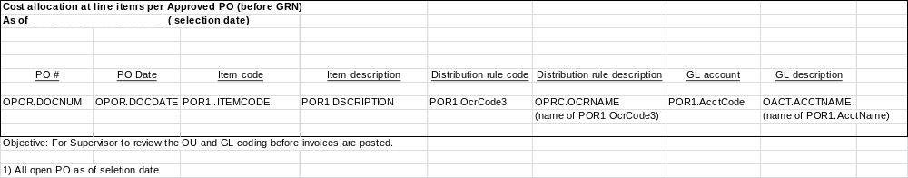

3.8.2 Cost Allocation at AP Invoice level

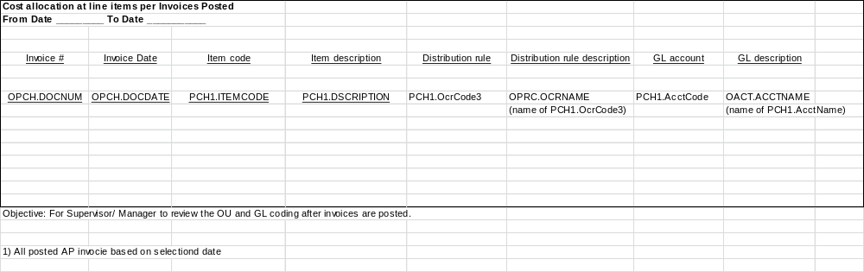

3.9 PO Aging Report

3.8.1 PO Aging report format and mapping

